Paediatric Clinical Leaders: Service Planning, Provision and Best Practice
836

‘For want of the bus fare’; a parent/carer and staff survey on the impact of travel costs on hospital attendance

- Chad Lambert1,2, David Gottlieb2, Anthony Cohn2

Abstract
Objectives Travel to and from healthcare facilities substantially contributes to the overall healthcare experience [1,2], whilst the cost of travel may be a barrier to accessing healthcare [3]. The NHS Healthcare Travel Cost Scheme (HTCS) was created to reimburse patients for reasonable travel costs if they meet certain financial criteria, such as being in receipt of government funded benefits or allowances [4]. Our study aimed to assess the impact of the cost of travel on healthcare attendance in a paediatric population. It also aimed to assess parent/carer and healthcare staff knowledge on the NHS HTCS.
Methods A cross-sectional survey was carried out between 20th February 2022 and 21st April 2022 in a large UK district general hospital paediatric department. A parent/carer survey assessed methods of travel to hospital, whether transport costs were a factor in accessing healthcare and ascertained awareness of any funding support for travel. The staff survey assessed awareness of funding support for patient travel, experiences of transport costs being a barrier for patients, and confidence in signposting to funding support.
Results 32 parents/carers and 27 healthcare staff completed the respective survey. 10/32 parents/carers said they worry about the travel cost when attending hospital for their child. 5/32 parents/carers reported previously not attending medical appointments for their children due to the cost of travel, as shown in Figure 1. Of the 5 patients who had missed medical appointments, only 1 was currently receiving income support or universal credit, and therefore 4/5 were not eligible for the HTSC. 8/32 parents/carers were aware that families may be eligible for funds to help with costs of travel for medical appointments.
11/27 healthcare staff reported they were aware of patients not attending appointments due to the cost of travel, whilst 5 staff were aware of funding schemes for supporting patient travel. Figure 2 shows 26/27 staff reported that they were either not confident or not at all confident in signposting patients to help with funding for patient travel.
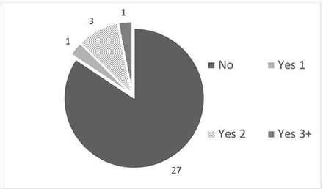
Abstract 836 Figure 1
The number of patients who have missed medical appointments due to the cost of travel, categorized by the number of appointments missed
Conclusion This study identified that, while the NHS strives to be ‘free at the point of use’, the cost of travel may represent an important financial barrier to accessing healthcare. It highlights that many healthcare staff are not aware of funding schemes available. The cost of travel warrants further study and implementation of measures to reduce this barrier to accessing healthcare, which is especially important in times of increased cost of living.
References
- B0682-fnal-report-of-the-non-emergency-patient-transport-review.pdf. https://www.england.nhs.uk/wp-content/uploads/2021/08/B0682-fnal-report-of-the-non-emergency-patient-transport-review.pdf (accessed 18 Jul 2022).
- Heath G, Greenfield S, Redwood S. The meaning of ‘place’ in families’ lived experiences of paediatric outpatient care in different settings: a descriptive phenomenological study. Health Place 2015;31:46–53. doi:10.1016/j.healthplace.2014.10.014
- Yang S, Zarr RL, Kass-Hout TA, et al. Transportation barriers to accessing health care for urban children. J Health Care Poor Underserved 2006;17:928–43. doi:10.1353/hpu.2006.0137
- Healthcare Travel Costs Scheme (HTCS). nhs.uk. 2020.https://www.nhs.uk/nhs-services/help-with-health-costs/healthcare-travel-costs-scheme-htcs/(accessed 19 Jul 2022).
http://dx.doi.org/10.1136/archdischild-2023-rcpch.522

